Major Project Report
On
“Hotel Reservation System”
Submitted for partial fulfilment of award of
Master of Computer Application

Department of Computer Application
At


KHANDELWAL COLLEGE OF MANAGEMENT SCIENCE AND TECHNOLOGY, BAREILLY AFFILIATED TO


DR. A. P. J. ABDUL KALAM TECHNICAL UNIVERSITY, LUCKNOW
(Session: 2025-2026)
Project Guide: Monu Kashyap
Mrs. Shivani Rastogi MCA 4th Sem
240142140015

CANDIDATE’S DECLARATION

I hereby declare that the work, which is being presented in the Major Project, entitled “Hotel Reservation System” in partial fulfilment for the award of Degree of “Masters of Computer Application” and submitted to the Department of Computer Science, Khandelwal College of Management Science and Technology, Bareilly affiliated to Dr. A. P. J. Abdul Kalam Technical University, Lucknow is a record of my own investigations carried under the Guidance of Guide Name
I have not submitted the matter presented in this Report anywhere for the award of any other Degree.

Date: ___________

\
CERTIFICATE

This is to certify that the Project Report entitled “Hotel Reservation System” submitted by Monu Kashyap to Khandelwal College of Management Science and Technology, Bareilly, affiliated to Dr. A.P.J. Abdul Kalam Technical University, Lucknow for the award of the Degree of Master of Computer Application is a record of Bonafede work carried out by her/his under my supervision. In my opinion, the project has reached the standards of fulfilling the requirements of the regulations to degree.

Guide Name: Mrs. Shivani Rastogi

ACKNOWLEDGEMENT

We would like to extend gratefulness to all those who have made this work possible. We thank our Director General Sir Dr. Amresh Kumar, for giving us this wonderful opportunity to use all that we have learnt in years and make something which could be proved beneficial to this society.
We also thank our Head of the Dept. Mr. Deepak Awasthi Sir and our project guide Mrs Shivani Rastogi , for their immense support and guidance throughout the development of the concept and idea.
We are also thankful to the faculty members of our department for giving us support and guidance at all the times we needed without their support the project and report would not have been possible. We have made possible efforts to make the report to the best of our abilities.
We are even grateful to various websites who helped us to get acquainted with some useful facts and data about the topic.
Any suggestions and comments would be highly appreciated and welcomed.

Monu Kashyap
MCA 4th Sem
240140140015

Table of Contents

ABSTRACT 1
CHAPTER 1: INTRODUCTION 6
CHAPTER 2: SCOPE OF THE PROJECT 7
CHAPTER 3: THEORETICAL BACKGROUND ………………………………..…………..8
CHAPTER 4: SYSTEM ANALYSIS, PLANNING AND DESIGN………….………………8
CHAPTER 5: SYSTEM PLANNING…………………………………………………………9
CHAPTER 6: SYSTEM DEVELOPMENT LIFE CYCLE …………………………………..11
CHAPTER 7: HARDWARE & SOFTWARE REQUIREMENT……………………………14
CHAPTER 8: ARCHITECTURE……………………………………………………………..16
CHAPTER 9: INPUT AND OUTPUT SCREEN ……………………………………………17
CHAPTER 10: MODULES AND FEATURES…………………………………………...…20
CHAPTER 11: FUTURE ENHANCEMENT………………………………………………..24
CHAPTER 12: CONCLUSION …26
APENDIX I: SOURCE CODE …………………………………………………………….27
REFERENCES

1: INTRODUCTION

The Hotel Reservation System is a software application designed to simplify and automate the process of booking hotel rooms. In today’s fast-paced digital world, customers expect quick, reliable, and convenient services, especially when it comes to travel and accommodation. Traditional methods of hotel booking, such as phone calls or manual record-keeping, are time-consuming, error-prone, and inefficient. To overcome these limitations, computerized reservation systems have become essential for modern hotel management.
This project focuses on developing a user-friendly and efficient system that allows customers to check room availability, make reservations, and manage bookings online. At the same time, it helps hotel administrators maintain accurate records of guests, rooms, payments, and booking details in a structured manner.
The system provides an interface for both users and administrators. Customers can view available rooms, select their preferred type, enter personal details, and confirm reservations. On the other hand, administrators can add or update room information, manage bookings, track customer data, and generate reports. This reduces manual workload and improves overall operational efficiency.
The main objective of this project is to design a system that ensures accuracy, speed, and convenience in handling hotel reservations. It minimizes human errors, enhances customer satisfaction, and provides secure data management. Additionally, the system can be expanded in the future to include features such as online payments, customer reviews, and mobile accessibility.
In conclusion, the Hotel Reservation System is an important step toward digital transformation in the hospitality industry. It not only improves the booking experience for customers but also streamlines hotel operations, making the entire process more organized and efficient.

2: SCOPE OF THE PROJECT

The scope of the Hotel Reservation System defines the boundaries and functionalities of the system, specifying what features are included and how the system will be used by both customers and hotel management.
This project is designed to develop a computerized system that automates the process of hotel room booking and management. It covers all essential operations required for handling reservations efficiently and accurately.
The main scope of the project includes:

- Online Room Booking
The system allows customers to check room availability in real time and book rooms according to their preferences, such as room type, number of guests, and duration of stay.
- Customer Management
The system stores and manages customer information, including personal details, booking history, and contact information, ensuring easy access and record maintenance.
- Room Management
Administrators can add, update, or delete room details such as room type, price, availability status, and facilities offered.
- Reservation Management
The system handles all booking-related activities, including new reservations, modifications, cancellations, and confirmation of bookings.
- Payment Handling (Basic Level)
The project may include basic payment recording features. Advanced online payment integration can be considered as a future enhancement.
- Report Generation
The system can generate reports related to bookings, customer details, room occupancy, and revenue, which helps in decision-making and management analysis.
- User Roles
The system supports different roles such as admin and customer, each having specific access and functionalities.

3: THEORETICAL BACKGROUND

The Hotel Reservation System is developed using the MERN stack, which is a modern web development framework consisting of MongoDB, Express.js, React.js, and Node.js. This stack enables the development of full-stack web applications using JavaScript for both frontend and backend.
3.1: FRONTEND (CLIENT-SIDE DEVELOPMENT)
The frontend of the Hotel Reservation System is developed using React.js, which provides a dynamic and responsive user interface. It allows users to interact with the system easily and efficiently.
The frontend is responsible for displaying information and collecting user input. It includes various pages such as the home page, login/register page, room listing page, booking page, and user dashboard.
TECHNOLOGIES USED:
- React.js
- HTML
- CSS
- JavaScript

3.2: BACKEND (SERVER-SIDE DEVELOPMENT)
The backend of the system is developed using Node.js and Express.js. It handles the business logic, database operations, and communication between the frontend and the database.
TECHNOLOGIES USED:
- Node.js
- Express.js
- MongoDB

4: SYSTEM ANALYSIS AND DESIGN
System analysis involves understanding the current system, identifying its limitations, and defining the requirements for the new system.
In traditional hotel management systems, booking and record-keeping are often done manually or using outdated software. This leads to inefficiencies, errors, and difficulty in managing large amounts of data.
The proposed Hotel Reservation System is a web-based application developed using the MERN stack. It aims to automate the booking process and improve overall system efficiency.
4.1 FUNCTIONAL REQUIREMENTS
- User registration and login
- Room search and availability check
- Room booking and cancellation
- Payment processing (optional)
- Admin management of rooms and bookings

4.2 NON-FUNCTIONAL REQUIREMENTS
- Performance: Fast response time
- Security: Secure user authentication
- Usability: Easy-to-use interface
- Scalability: Can handle multiple users
- Reliability: System should be available at all times

4.3 SYSTEM DESIGN
System design defines how the system will be built and how its components interact.

Architecture Design
- Presentation Layer: React.js (User Interface)
- Application Layer: Node.js + Express.js (Server logic)
- Data Layer: MongoDB (Database)

5: SYSTEM PLANNING
System planning is the initial phase of system development in which the objectives, scope, resources, and schedule of the project are defined. It helps in organizing the development process and ensures that the project is completed successfully within the given time.

5.1 PROJECT OVERVIEW
The Hotel Reservation System is a web-based application developed using the MERN stack. The main goal of this project is to provide an efficient and user-friendly platform for booking hotel rooms online.

5.2 OBJECTIVES OF SYSTEM PLANNING
- To define the scope of the project
- To identify required resources
- To allocate time for each phase
- To ensure proper project management
- To minimize risks during development

5.3 SCOPE OF THE PROJECT
The system will allow users to:
- Register and log in
- Search for available rooms
- Book rooms online
- View and manage bookings
The admin will be able to:
- Add, update, or delete room details
- Manage bookings
- Monitor system activities

5.4 HUMAN RESOURCES
- Developer (You)
- Project Guide
5.5 HARDWARE RESOURCES
- Computer/Laptop
- Internet connection
5.6 SOFTWARE RESOURCES
- Frontend: React.js
- Backend: Node.js, Express.js
- Database: MongoDB
- Tools: VS Code, Web Browser

5.7 TIME PLANNING (PROJECT SCHEDULE)

Phase | Duration
Requirement Analysis | 1 Week
System Design | 1 Week
Development (Coding) | 2–3 Weeks
Testing | 1 Week
Documentation | 1 Week

6: SOFTWARE DEVELOPMENT LIFE CYCLE (SDLC)

The Software Development Life Cycle (SDLC) is a structured process used to develop high-quality software in a systematic and efficient manner. It consists of different phases that guide the development of the Hotel Reservation System from planning to maintenance.

6.1 PLANNING PHASE
In this phase, the project goals, scope, and feasibility are defined. Resources, time, and cost are estimated to ensure proper project execution.
Activities:
- Identifying project objectives
- Defining scope
- Resource and time planning

6.2 REQUIREMENT ANALYSIS PHASE
In this phase, the system requirements are collected and analyzed. Both functional and non-functional requirements are identified.
Examples in this project:
- User registration and login
- Room booking and cancellation
- Admin management system

6.3 SYSTEM DESIGN PHASE
In this phase, the overall system architecture and design are created. It includes database design, system structure, and module design.
Design includes:
- MERN stack architecture
- Database schema (MongoDB collections)
- User interface design

6.4 IMPLEMENTATION (DEVELOPMENT) PHASE
In this phase, the actual coding of the system is done using selected technologies.
In this project:
- Frontend developed using React.js
- Backend developed using Node.js and Express.js
- Database managed using MongoDB

5. TESTING PHASE
In this phase, the system is tested to identify and fix errors.
Types of Testing:
- Unit Testing
- Integration Testing
- System Testing
- User Acceptance Testing

6. DEPLOYMENT PHASE
After testing, the system is deployed for use. It can be hosted on a server so that users can access it.

7. MAINTENANCE PHASE
This phase involves updating and improving the system after deployment.
Activities:
- Bug fixing
- Performance improvement
- Adding new features

7: HARDWARE AND SOFTWARE REQUIREMENTS

1. HARDWARE REQUIREMENTS
The development and execution of the Hotel Reservation System using MERN stack require the following hardware components:
Minimum Requirements:
- Processor: Intel Core i3 or equivalent
- RAM: 4 GB
- Storage: 256 GB Hard Disk / SSD
- Display: Standard monitor (1366 × 768 resolution)
- Input Devices: Keyboard and Mouse
Recommended Requirements:
- Processor: Intel Core i5 or higher
- RAM: 8 GB or more
- Storage: 512 GB SSD
- Internet Connection: Stable broadband connection for development and testing

2. SOFTWARE REQUIREMENTS
The MERN stack consists of four main technologies used to build full-stack web applications:
a) Frontend Technologies
- React
Used for building interactive and dynamic user interfaces. It allows component-based architecture for better code reusability.
- HTML5, CSS3, JavaScript
Used for structuring, styling, and adding functionality to web pages.
- Browser:
  - Google Chrome (preferred)
  - Mozilla Firefox / Microsoft Edge
b) Backend Technologies
- Node.js
Used to run JavaScript on the server side.
- Express.js
A lightweight framework used to build APIs and handle server-side logic.
c) Database
- MongoDB
A NoSQL database used to store data in JSON-like format, suitable for scalable applications.
d) Development Tools
- Visual Studio Code
Used for writing and managing code efficiently.
- Git
Used for version control and collaboration.
- Postman
Used to test backend APIs.
- npm
Used to install and manage project dependencies.

e) Operating System
- Windows 10 / 11
- Linux (Ubuntu)
- macOS

8: ARCHITECTURE REPORT
The Hotel Reservation System is a full-stack web application built using the MERN Stack — MongoDB, Express.js, React.js, and Node.js. This system allows guests to search and book hotel rooms online, while hotel owners can manage their properties, rooms, and bookings through a dedicated dashboard. The architecture is designed to be scalable, secure, and maintainable

TECHNOLOGY ARCHITECTURE
TECHNOLOGY | ROLE | DESCRIPTION
MongoDB | Database | Stores all data — users, hotels, rooms, bookings
Express.js | Backend Framework | Handles API routes and server logic
React.js | Frontend | User interface for guests and hotel owners
Node.js | Runtime Environment | Runs JavaScript on the server side

SYSTEM ARCHITECTURE

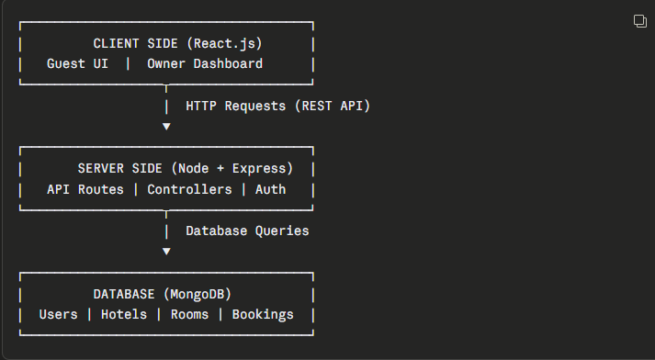

FRONTEND ARCHITECTURE (REACT.JS)
The frontend is built with React.js and handles everything the user sees and interacts with.
Key Libraries Used:
- React Router DOM — for page navigation (Home, Rooms, SingleRoom, MyBookings)
- Context API — for global state management (user, owner, hotel data)
- Axios — for making API calls to the backend
- Tailwind CSS — for styling and responsive design
- Framer Motion — for animations
- React Hot Toast — for notifications

BACKEND ARCHITECTURE (NODE.JS + EXPRESS.JS)

The backend is a REST API server built with Node.js and Express.js. It receives requests from the frontend, processes the business logic, and returns responses.
Key Libraries Used:

- Express.js — API routing and middleware
- Mongoose — MongoDB object modeling
- JWT (JSON Web Token) — authentication and authorization
- Bcrypt.js — password hashing
- Cors — cross-origin requests handling
- Dotenv — environment variable management
- Multer / Cloudinary — image upload handling

9: INPUT AND OUTPUT SCREEN
Input screens are used to collect data from the user and store it in the system. In the Hotel Reservation System, various input forms are designed using React.js to interact with users.

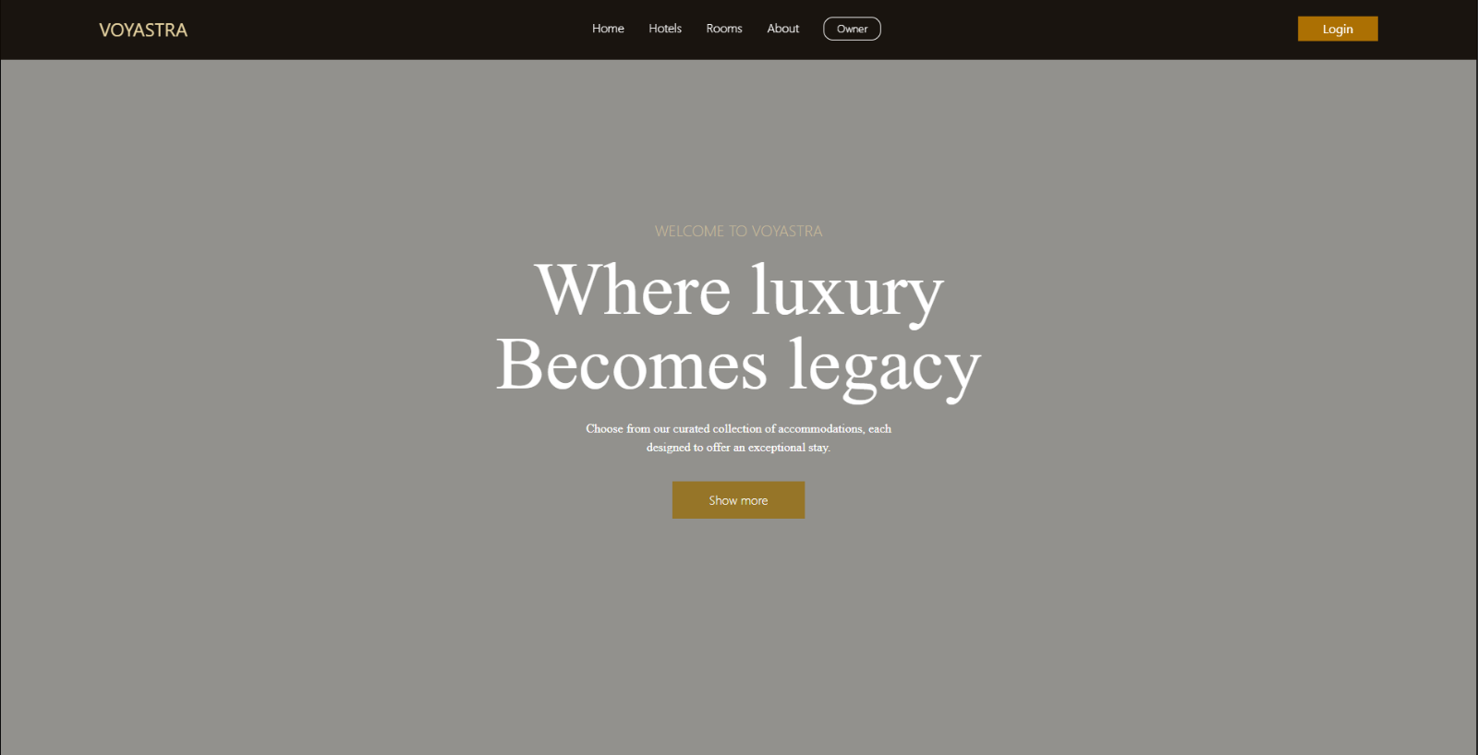

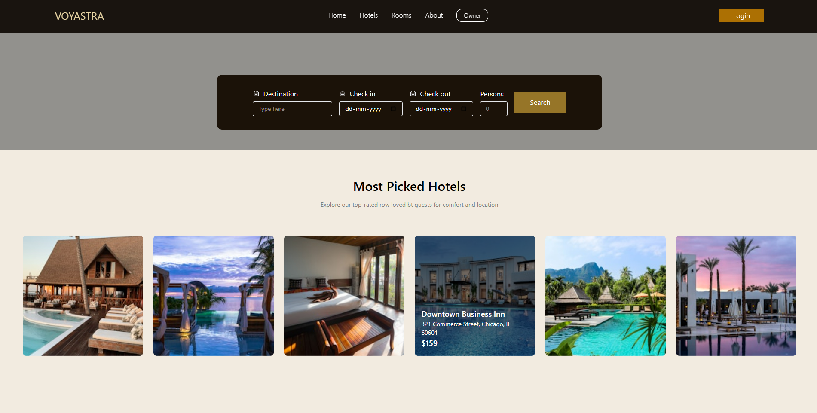

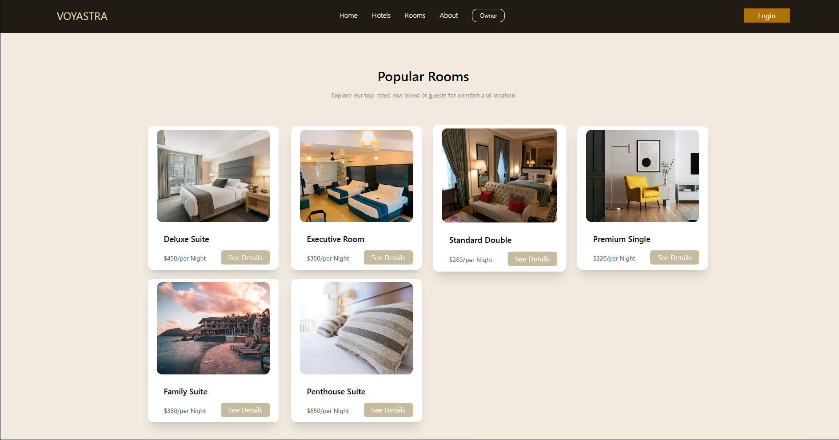

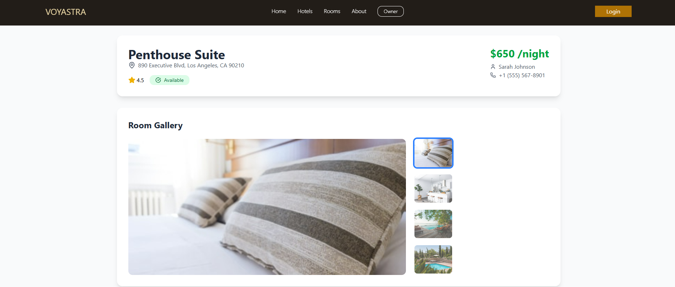

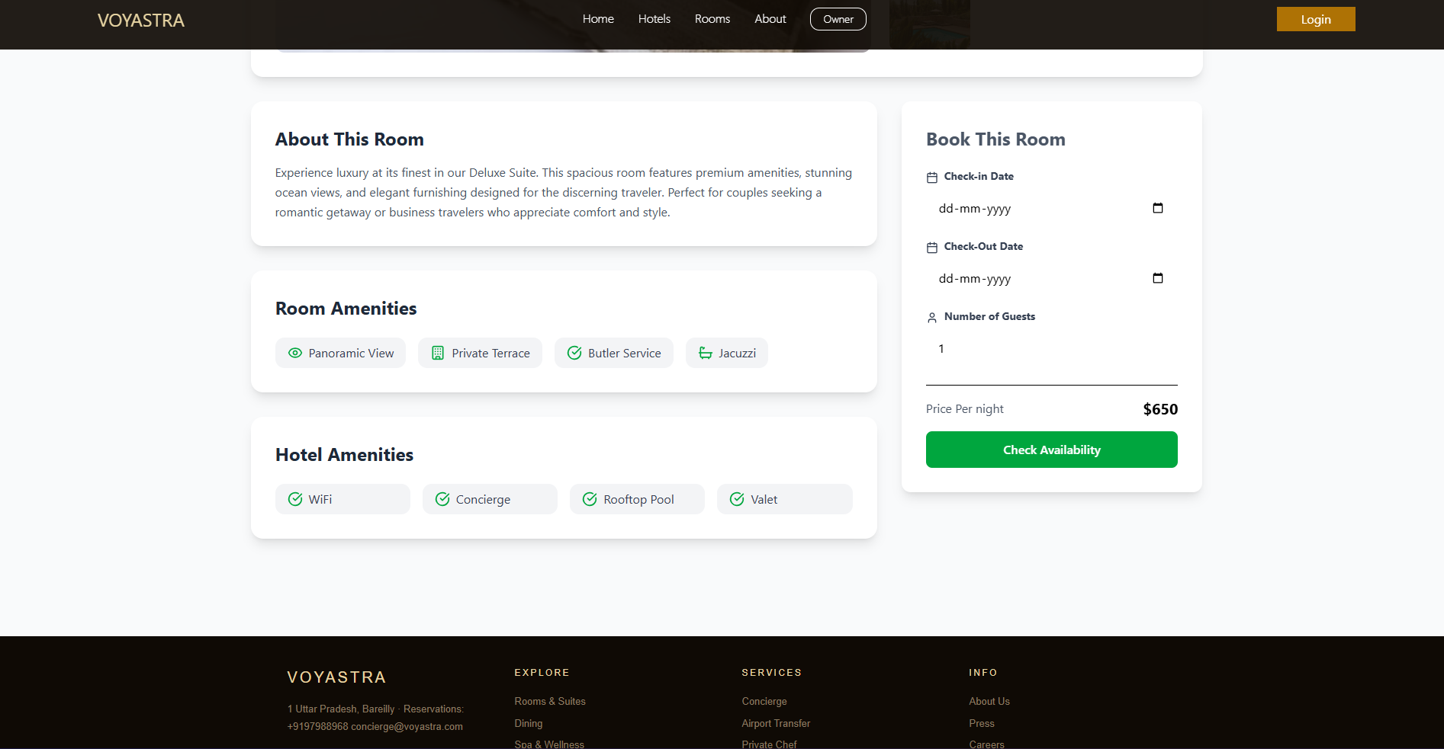

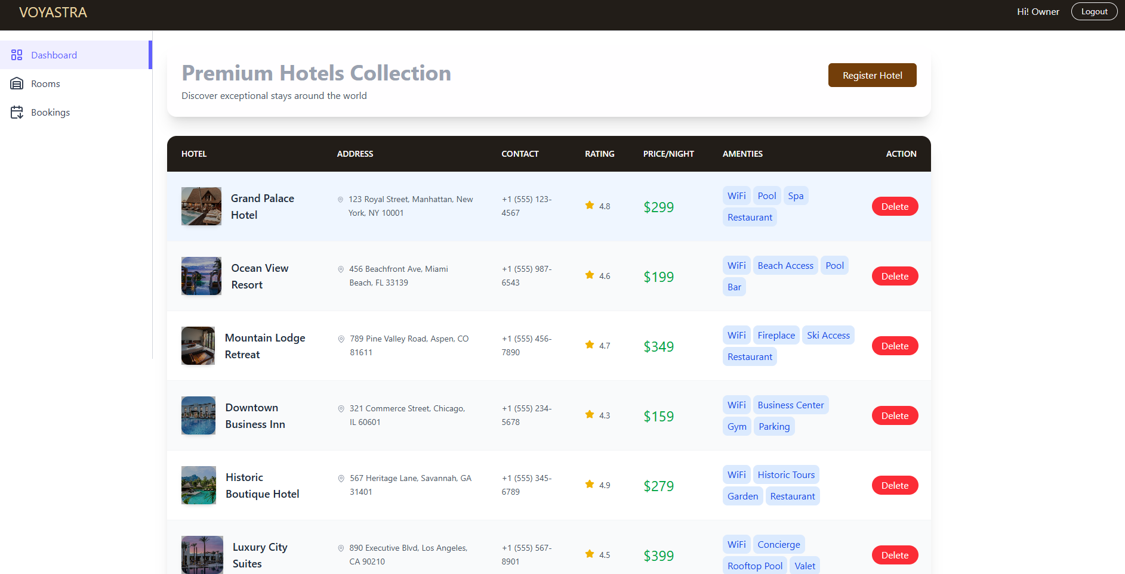

10: MODULES AND FEATURES

Module 1: Authentication Module
This module handles all user registration, login, and access control for the entire system.
Features:
User Registration Any new user — whether a guest or hotel owner — can create an account by providing their full name, email address, and password. The password is securely hashed using Bcrypt.js before storing in the database so that no plain text password is ever saved.
User Login Registered users can log in using their email and password. Upon successful login, the backend generates a JWT (JSON Web Token) which is sent to the frontend and stored. This token is then used to authenticate all future requests.
Role-Based Access Control The system has two roles — Guest and Owner. Based on the role, different pages and features are accessible. A guest cannot access the owner dashboard and an owner gets extra privileges to manage hotels and rooms.
Protected Routes All sensitive pages like My Bookings, Owner Dashboard, Add Room, and Register Hotel are protected. If a user tries to access these pages without logging in, they are automatically redirected to the Login page.
Logout Users can log out at any time. On logout the JWT token is cleared and the user is redirected to the home page.

Module 2: Guest Module
This module covers everything a guest can do on the platform — from browsing hotels to managing their bookings.
Features:
Home Page The home page is the first page a guest sees. It displays featured hotels, top-rated rooms, a search bar, and promotional banners. It gives the guest a quick overview of what the platform offers.
Hotel & Room Search Guests can search for available rooms by location, check-in date, check-out date, and number of guests. The search results display all matching rooms with images, price per night, amenities, and ratings.
Room Listing Page All available rooms are displayed as cards on the Rooms page. Each card shows the room image, room type, price per night, and a "See Details" button. Rooms are displayed in a clean grid layout.
Single Room Detail Page When a guest clicks on a room card, they are taken to the Single Room page. This page shows a full image gallery, complete list of amenities with icons, room description, price breakdown, hotel name and address, and a booking form.
Room Gallery On the Single Room page, a large main image is shown along with thumbnail images below. The guest can click on any thumbnail to view that image as the main image.
Amenities Display All room amenities like Free WiFi, Pool Access, Parking, Breakfast Included, etc. are displayed with relevant icons so guests can quickly understand what is included.
My Bookings Page Guests can view all their past and current bookings in one place. Each booking card shows hotel name, room type, check-in and check-out dates, total price, payment status (Paid/Unpaid), and booking status (Confirmed, Pending, Cancelled, Completed).
Booking Cancellation If a booking status is not already Cancelled, the guest can cancel it by clicking the Cancel button on the My Bookings page.

Module 3: Booking Module
This module handles the complete booking lifecycle — from creation to cancellation.
Features:
Room Availability Check Before confirming a booking, the system checks whether the selected room is available for the requested dates. This prevents double booking of the same room.
Booking Creation Once a guest selects a room and enters check-in and check-out dates, the system calculates the total price automatically based on the number of nights and price per night. The booking is then saved in the database with all details.
Total Price Calculation
Total Price = Price Per Night × Number of Nights
Example: ₹2500 × 5 nights = ₹12,500
Payment Integration The system records the payment method used by the guest — Credit Card, Debit Card, UPI, or Net Banking. Payment status is tracked as Paid or Unpaid.
Booking Status Tracking Every booking has a real-time status that updates throughout its lifecycle:
Booking Created → Pending
Payment Done → Confirmed
Stay Completed → Completed
Guest Cancels → Cancelled
Booking Confirmation After successful booking, the guest receives a confirmation notification on screen via toast message and all booking details are saved and visible in My Bookings page.
Check-in & Check-out Date Display Booking dates are displayed in a clean readable format — for example "Mon, Apr 10" instead of raw date strings — using JavaScript's date formatting.

Module 4: Hotel Owner Module
This module gives hotel owners a separate and powerful dashboard to manage their entire hotel business on the platform.
Features:
Owner Dashboard After logging in as an owner, a dedicated sidebar dashboard opens. The dashboard has a professional layout with a top navbar showing owner name and logout button, and a left sidebar with navigation links to all owner features.
Hotel Registration Owners can register their hotel by filling a form with hotel name, description, address, rating, price, and uploading multiple hotel images. Once submitted, the hotel is listed on the platform and visible to guests.
Add Room Owners can add rooms to their registered hotel. For each room they provide room type (Deluxe, Suite, Standard etc.), price per night, amenities, and room images. Multiple rooms can be added to a single hotel.
View All Hotels Owners can see a list of all hotels they have registered on the platform with basic details like name, address, rating, and number of rooms.
View All Rooms Owners can view all rooms they have added across all their hotels with availability status, price, and room type.
Manage Bookings Owners can see all bookings made by guests for their hotels. Each booking entry shows guest name, room type, check-in and check-out dates, total amount, and payment status. This helps owners plan room availability efficiently.
Sidebar Navigation The owner dashboard has a clean responsive sidebar that collapses to icon-only view on mobile and expands to full text on desktop for better usability.

Module 5: Admin / Platform Module
This module handles the overall platform management and ensures smooth operations.
Features:
Global State Management Using React Context API, the platform maintains global state across all pages — including logged-in user data, owner data, hotel listings, and navigation function. This ensures all components have access to the data they need without unnecessary prop drilling.
Dynamic Routing React Router DOM manages all page navigation. Public routes are accessible to everyone while protected routes check authentication before allowing access. Owner routes are nested under the /owner path for clean URL structure.
Toast Notifications React Hot Toast is used throughout the platform to show real-time success and error messages — for example "Booking Confirmed!", "Login Successful", or "Please fill all fields."
Responsive Design The entire platform is built with Tailwind CSS and is fully responsive — it works perfectly on mobile phones, tablets, and desktop computers. The layout adjusts automatically based on screen size.
Image Upload & Gallery Hotel and room images can be uploaded by owners. Multiple images are supported and displayed in a gallery format with thumbnail navigation on the room detail page.
Error Handling All API calls are wrapped in try-catch blocks. If something goes wrong — like a network error or invalid data — a proper error message is shown to the user instead of crashing the app.

11: FUTURE ENHANCEMENT

1. AI-Powered Smart Recommendations
Currently the platform shows all rooms to all users. In the future an Artificial Intelligence based recommendation engine will be integrated. This system will analyze each guest's booking history, preferred room types, budget range, and location preferences. Based on this data it will automatically suggest the most relevant hotels and rooms to each individual guest. This will make the booking experience more personalized and increase the chances of conversion.
Planned Features:
- AI-based room suggestions on home page
- "You May Also Like" section on room detail page
- Smart price range suggestions based on user history
- Personalized email recommendations

2. Real-Time Payment Gateway Integration
Currently the system records payment method but does not process actual payments. In the future a complete payment gateway will be integrated to handle real money transactions securely.
Planned Integrations:
- Razorpay — for Indian market UPI, Net Banking, Cards
- Stripe — for international credit and debit card payments
- PayPal — for global guest payments
- EMI Options — guests can pay in installments for expensive bookings
- Automatic Refunds — on booking cancellation refund will be processed automatically

3. Real-Time Chat Support
Currently there is no live communication between guests and hotel owners. In the future a real-time chat system will be built using Socket.io so that guests can directly message hotel owners to ask questions about rooms, facilities, check-in time, or any special requests.
Planned Features:
- Guest to Owner live chat
- Platform support chatbot for common queries
- Chat history saved for reference
- File and image sharing in chat
- Automated replies for common questions

4. Mobile Application
Currently the system is a web application accessible through browsers. In the future a dedicated mobile application will be developed for both Android and iOS platforms using React Native. Since most travelers use their phones to search and book hotels, a mobile app will significantly increase the platform's reach and user engagement.
Planned Features:
- Full booking functionality on mobile
- Push notifications for booking confirmations
- GPS-based hotel search — find hotels near current location
- Offline booking history access
- Fingerprint and Face ID login

5. Advanced Search and Filters
Currently the search functionality is basic. In the future a much more advanced search and filtering system will be implemented so guests can find exactly what they are looking for very quickly.
Planned Filters:
- Price range slider (minimum to maximum per night)
- Star rating filter (1 star to 5 star)
- Amenity-based filter (WiFi, Pool, Parking, Breakfast etc.)
- Room type filter (Standard, Deluxe, Suite, Villa)
- Distance from city center or landmark
- Guest reviews score filter
- Instant booking availability filter

12: CONCLUSION

The Hotel Reservation System is a fully functional, modern, and responsive web application developed using the MERN Stack — MongoDB, Express.js, React.js, and Node.js. This project was built with the goal of solving real-world problems faced by both travelers and hotel owners in the traditional hotel booking process. The platform successfully bridges the gap between guests who are looking for comfortable accommodation and hotel owners who want to reach a wider audience and manage their bookings efficiently.

2. What We Achieved
Through this project we successfully designed, developed, and tested a complete hotel reservation platform that covers the entire booking lifecycle — from user registration to room booking to booking management. The system was built with clean code architecture, proper separation of concerns, and industry-standard technologies that are widely used in real-world production applications today.
Key Achievements:
The project successfully implemented a secure authentication system using JWT tokens and Bcrypt password hashing that protects all user data and ensures only authorized users can access sensitive features. Role-based access control was implemented that cleanly separates guest and owner functionalities.
A complete guest experience was built where any user can visit the platform, browse available hotels and rooms, view detailed room information with image galleries and amenities, make bookings with automatic price calculation, and manage all their bookings from a single dashboard.
A dedicated hotel owner dashboard was developed with full property management capabilities including hotel registration, room addition, booking management, and real-time status tracking. This gives hotel owners complete control over their listings.
A robust booking module was implemented that handles room availability checking, price calculation based on number of nights, payment status tracking, and booking status management through its complete lifecycle from Pending to Confirmed to Completed or Cancelled.
The entire application is fully responsive and works seamlessly across all devices — mobile phones, tablets, and desktop computers — ensuring maximum accessibility for all users regardless of the device they use.

CHALLENGES FACED AND OVERCOME
During the development of this project we encountered several technical challenges that required research, debugging, and creative problem solving.
Route Management Challenge — Managing complex routing with both public routes for guests and protected nested routes for owners required careful planning. We solved this by implementing React Router DOM with proper nested route structure and authentication guards.
State Management Challenge — Sharing data like user information and hotel listings across multiple components without prop drilling was challenging. We solved this by implementing React Context API which provides global state accessible throughout the application.
Authentication Challenge — Implementing secure JWT-based authentication with proper token storage and middleware verification required deep understanding of security concepts. This was successfully implemented with proper role checking on both frontend and backend.
Responsive Design Challenge — Making the owner dashboard sidebar responsive — showing full text on desktop and icon-only on mobile — required careful Tailwind CSS configuration and testing across multiple screen sizes.

SOURCE CODE

FRONTEND SOURCE CODE

import React from "react";
import { cities } from "../assets/assets";

function Hero() {
return (
<>
<main
className="flex flex-col w-full h-screen md:flex-row items-center max-md:text-center
sm:px-10 md:px-20 max-w-7xl justify-center mx-auto

"
>
{/* first div */}
<div className="flex flex-col justify-center items-center text-center">
<p
className="text-heading text-2xl sm:text-4xl md:text-xl max-w-2xl leading-tight text-[#C6BB9C] font-thin
"
>
{" "}
WELCOME TO VOYASTRA
</p>
<h3 className="w-full font-frukturn mt-2 max-w text-6xl md:text-8xl text-[#FFFFFF] leading-relaxe py-2 font-thin">
Where luxury <br />{" "}
<span className="font-frukturn font-thin mt-2">
Becomes legacy
</span>
</h3>
<p className="mt-4 text-[#FFFFFF] text-center w-2/3 font-frukturn">
Choose from our curated collection of accommodations, each designed
to offer an exceptional stay.
</p>
<div className="flex flex-col md:flex-row items-center mt-8 gap-3">
<button className="bg-[#967528] font-thin text-white px-12 py-3 flex items-center cursor-pointer hover:bg-[#695015]">
Show more
</button>
</div>
</div>

{/* second */}
<div>
<button></button>
</div>
</main>
{/* form for the detination moments */}
<form className=" justify-center items-center max-w-4xl rounded-xl mb-5 w-full mx-auto bg-[#1b1208] text-gray-900 px-6 py-8 flex flex-col md:flex-row max-md:items-start gap-4 max-md:mx-auto">
<div className="text-[#FFFFFF] ">
<div className="flex items-center gap-2 ">
<svg
className="w-4 h-4 text-gray-200"
aria-hidden="true"
xmlns="http://www.w3.org/2000/svg"
width="24"
height="24"
fill="none"
viewBox="0 0 24 24"
>
<path
stroke="currentColor"
strokeLinecap="round"
strokeLinejoin="round"
strokeWidth="2"
d="M4 10h16M8 14h8m-4-7V4M7 7V4m10 3V4M5 20h14a1 1 0 0 0 1-1V7a1 1 0 0 0-1-1H5a1 1 0 0 0-1 1v12a1 1 0 0 0 1 1Z"
/>
</svg>
<label htmlFor="destinationInput">Destination</label>
</div>
<input
list="destinations"
id="destinationInput"
type="text"
className=" rounded border border-gray-200 px-3 py-1.5 mt-1.5 text-sm outline-none"
placeholder="Type here"
required
/>
<datalist id="destinations">
{cities.map((city, index) => (
<option key={index} value={city} />
))}
</datalist>
</div>

<div>
<div className="flex items-center gap-2 text-[#FFFFFF] ">
<svg
className="w-4 h-4 text-gray-200"
aria-hidden="true"
xmlns="http://www.w3.org/2000/svg"
width="24"
height="24"
fill="none"
viewBox="0 0 24 24"
>
<path
stroke="currentColor"
strokeLinecap="round"
strokeLinejoin="round"
strokeWidth="2"
d="M4 10h16M8 14h8m-4-7V4M7 7V4m10 3V4M5 20h14a1 1 0 0 0 1-1V7a1 1 0 0 0-1-1H5a1 1 0 0 0-1 1v12a1 1 0 0 0 1 1Z"
/>
</svg>
<label htmlFor="checkIn">Check in</label>
</div>
<input
id="checkIn"
type="date"
className=" rounded border border-gray-200 px-3 py-1.5 mt-1.5 text-sm outline-none text-[#FFFFFF]"
/>
</div>

<div>
<div className="flex items-center gap-2 text-[#FFFFFF] ">
<svg
className="w-4 h-4 text-gray-200 "
aria-hidden="true"
xmlns="http://www.w3.org/2000/svg"
width="24"
height="24"
fill="none"
viewBox="0 0 24 24"
>
<path
stroke="currentColor"
strokeLinecap="round"
strokeLinejoin="round"
strokeWidth="2"
d="M4 10h16M8 14h8m-4-7V4M7 7V4m10 3V4M5 20h14a1 1 0 0 0 1-1V7a1 1 0 0 0-1-1H5a1 1 0 0 0-1 1v12a1 1 0 0 0 1 1Z"
/>
</svg>
<label htmlFor="checkOut">Check out</label>
</div>
<input
id="checkOut"
type="date"
className=" rounded border border-gray-200 px-3 py-1.5 mt-1.5 text-sm outline-none text-[#FFFFFF]"
/>
</div>

<div className="flex md:flex-col max-md:gap-2 max-md:items-center text-[#FFFFFF] ">
<label htmlFor="guests">Persons</label>
<input
min={1}
max={4}
id="guests"
type="number"
className=" rounded border border-gray-200 px-3 py-1.5 mt-1.5 text-sm outline-none max-w-16"
placeholder="0"

/>
</div>

<button className="flex items-center justify-center gap-1 bg-[#967528] py-3 px-9 text-white my-auto cursor-pointer max-md:w-full max-md:py-1">
<span>Search</span>
</button>
</form>
</>
);
}

export default Hero;

NAVBAR

import React, { useContext } from "react";
import { AppContext } from "../content/AppContext";
import { useNavigate } from "react-router-dom";
import Login from "../pages/Login";
import { Link } from "react-router-dom";
import {assets }from "../assets/assets.js";
import toast from "react-hot-toast";

export default function Navbar() {
const {Navigate, user ,setUser } = useContext(AppContext)
const navigate = useNavigate();
const navLinks = [
{ name: 'Home', path: '/' },
{ name: 'Hotels', path: '/hotel' },
{ name: 'Rooms', path: '/rooms' },
{ name: 'About', path: '/about' },
];

const [isMenuOpen, setIsMenuOpen] = React.useState(false);

const logout = () =>{
setUser(false);
toast.success("Logout Successfully");
navigate("/");
}

return (
<div className="h-75 md:h-20 ">

<nav className={`fixed top-0 left-0 bg-[rgba(15,10,4,0.92)] w-full flex items-center justify-between px-4 md:px-16 lg:px-24 xl:px-32 transition-all duration-500 z-50 py-4 md:py-6`}>

{/* Logo */}
<a href="#" className=" flex items-start ">
<h1 className="text-[#e8d5a3] text-2xl ">VOYASTRA </h1>

</a>

{/* Desktop Nav */}
<div className="hidden md:flex items-center gap-4 lg:gap-8 text-white font-thin">
{navLinks.map((link, i) => (
<a key={i} href={link.path} className={`group flex flex-col gap-0.5text-white/70 hover:text-yellow-200`}>
{link.name}
<div className={` bg-white h-0.5 w-0 group-hover:w-full transition-all duration-300`} />
</a>
))}
<button className={`border px-4 py-1 text-sm font-light rounded-xl cursor-pointer text-white transition-all hover:text-yellow-200`}>
Owner
</button>
</div>

{/* Desktop Right */}
<div className="hidden md:flex items-center gap-4">

{ user ? (
<div className="relative group inline-block">
<img
src={assets.profile_icon}
alt=""
className="w-8 h-8 rounded-full border-2 border-gray-300 cursor-pointer"
/>

<div className="bg-white shadow-lg border border-gray-300 rounded-md opacity-0 group-hover:opacity-100
group-hover:visible invisible transition duration-300 z-50 absolute right-0 mt-2 w-40
">
<ul className="py-1">
<li>
<Link to = "/my-bookings" className="cursor-pointer block px-2 py-1 text-sm text-gray-700 hover:bg-gray-200 " >My-Booking</Link>
</li>
<li>
<button className="cursor-pointer block px-2 py-2 text-sm text-gray-700 hover:bg-gray-200 " onClick={logout}>Logout</button>
</li>
</ul>
</div>
</div>
) : (
<button
onClick={()=>{navigate("/login")}}
className={"px-8 py-1 ml-4 transition-all duration-500 text-white bg-yellow-600/80 hover:bg-yellow-600/70 cursor-pointer"}>
Login
</button>
)
}
</div>

{/* Mobile Menu Button */}
<div className="flex items-center gap-3 md:hidden">
<svg onClick={() => setIsMenuOpen(!isMenuOpen)} className={`h-6 w-6 cursor-pointer ""}`} fill="none" stroke="currentColor" strokeWidth="2" viewBox="0 0 24 24">
<line x1="4" y1="6" x2="20" y2="6" />
<line x1="4" y1="12" x2="20" y2="12" />
<line x1="4" y1="18" x2="20" y2="18" />
</svg>
</div>

{/* Mobile Menu */}
<div className={`fixed top-0 left-0 w-full h-screen bg-white text-base flex flex-col md:hidden items-center justify-center gap-6 font-medium text-gray-800 transition-all duration-500 ${isMenuOpen ? "translate-x-0" : "-translate-x-full"}`}>
<button className="absolute top-4 right-4" onClick={() => setIsMenuOpen(false)}>
<svg className="h-6 w-6" fill="none" stroke="currentColor" strokeWidth="2" viewBox="0 0 24 24">
<line x1="18" y1="6" x2="6" y2="18" />
<line x1="6" y1="6" x2="18" y2="18" />
</svg>
</button>

{navLinks.map((link, i) => (
<a key={i} href={link.path} onClick={() => setIsMenuOpen(false)}>
{link.name}
</a>
))}

<button className="border px-4 py-1 text-sm font-light rounded-full cursor-pointer transition-all">
Owner
</button>

<button
onClick={()=>{navigate("/login")}}
className="bg-black text-white px-8 py-2.5 rounded-full transition-all duration-500">

Login
</button>
</div>
</nav>
</div>
);
}

import React, { useContext } from "react";
import { AppContext } from "../../content/AppContext";
import { useNavigate } from "react-router-dom";
import { MapPin } from "lucide-react";
import {Star} from "lucide-react";
import RegisteredHotel from "./RegisteredHotel";

export default function AllHotels() {
const navigate = useNavigate();
const { hotelData } = useContext(AppContext);
return (
<div className="min-h-screen bg:gradient-to-b from-blue-50 to-indigo-100 p-6">
<div className="max-w-7xl mx-auto ">
{/* header */}
<div
className="mb-8 flex flex-col md:flex-row justify-between items-center
bg-white/50 rounded-2xl shadow-xl p-6 "
>
<div>
<h1 className="text-4xl font-bold text-gray-400 mb-2">
Premium Hotels Collection
</h1>
<p className="text-gray-600">
Discover exceptional stays around the world
</p>
</div>
<button
className="bg-yellow-900 ml-4 text-white px-6 py-2 mb-5 rounded-md cursor-pointer"
onClick={() => navigate("/owner/register-hotel")}
>
Register Hotel
</button>
</div>
{/* hotel table */}
<div className="bg-white rounded-2xl shadow-xl overflow-hidden">
<div className="overflow-x-auto">
<table className="w-full">
<thead className="bg-[rgba(15,10,4,0.92)] text-white ">
<tr>
<th className="px-6 py-5 text-left text-sm font-semibold uppercase tracking-winder">
Hotel
</th>

<th className="px-6 py-5 text-left text-sm font-semibold uppercase tracking-winder">
Address
</th>
<th className="px-6 py-5 text-left text-sm font-semibold uppercase tracking-winder">
Contact
</th>
<th className="px-6 py-5 text-left text-sm font-semibold uppercase tracking-winder">
Rating
</th>
<th className="px-6 py-5 text-left text-sm font-semibold uppercase tracking-winder">
Price/Night
</th>
<th className="px-6 py-5 text-left text-sm font-semibold uppercase tracking-winder">
Amenties
</th>
<th className="px-6 py-5 text-left text-sm font-semibold uppercase tracking-winder">
Action
</th>
</tr>
</thead>
<tbody className="divide-y divide-gray-100">
{hotelData.map((hotel, index) => (
<tr
key={hotel.id}
className={`hover:bg-blue-50 transition-all duration-200 ${
index % 2 === 0 ? " bg-white" : "bg-gray-50"
}`}
>
<td className="px-6 py-6">
<div className="flex items-center space-x-4">
<div className="relative">
<img
src={hotel.image}
alt={hotel.name}
className="w-20 h-16 rounded-xl object-cover shadow-md"
/>
<div className="absolute inset-0 bg-black/30 hover:bg-black/60 transition-all duration-200 "></div>
</div>
<div>
<h3 className="text-lg font-semibold text-gray-800 hover:text-blue-600 transition-colors">
{hotel.name}
</h3>
</div>
</div>
</td>

<td className="px-6 py-6">
<div className="flex items-starts space-x-2">
<MapPin className='w-4 h-4 text-gray-400 mt-1 flex-shrink-0"' />
<span className="text-gray-600 text-sm leading-relaxed">
{hotel.address}
</span>
</div>
</td>

<td className="px-6 py-6">
<div className="flex items-starts space-x-2">
<span className="text-gray-600 text-sm leading-relaxed">
{hotel.contactNumber}
</span>
</div>
</td>

<td className="px-6 py-6">
<div className="flex items-starts space-x-2">
<Star className="w-4 h-4 text-yellow-500 flex-shrink-0 fill-current"/>
<span className="text-gray-600 text-sm leading-relative">
{hotel.rating}
</span>

</div>
</td>
<td className="px-6 py-6">

<span className="text-green-600 text-2xl leading-relaxed">
{hotel.price}
</span>

</td>
<td className="px-6 py-6">
<div className="flex flex-wrap gap-1">
{
hotel.amenities.slice(0,4).map((item,index)=>(
<span key={index} className=" bg-blue-100 text-blue-700 px-2 py-1 rounded-lg ">
{item}
</span>
))
}
</div>
</td>
<td>
<button className="bg-red-500 text-white px-4 py-1 rounded-full cursor-pointer">Delete</button>
</td>
</tr>
))}
</tbody>
</table>
</div>
</div>
</div>
</div>
);
}

MY BOOKING

import React from "react";
import { bookingData } from "../assets/assets";
import {
MapPin,
Calendar,
Users,
CreditCard,
CheckCircle,
Clock,
XCircle,
Eye,
Trash2,
User,
Home,
} from "lucide-react";

export default function MyBooking() {
const getStatusColor = (status) => {
switch (status) {
case "Confirmed":
return "text-green-600 bg-green-50";
case "Cancelled":
return "text-red-600 bg-red-50";
case "Pending":
return "text-yellow-600 bg-yellow-50";
case "Completed":
return "text-blue-600 bg-blue-50";
default:
return "text-gray-600 bg-gray-50";
}
};
const getStatusTextColor = (Status) => {
switch (Status) {
case "Confirmed":
return "text-green-600";
case "Cancelled":
return "text-red-600";
case "Pending":
return "text-yellow-600";
case "Completed":
return "text-blue-600";
default:
return "text-gray-600";
}
};
const getStatusIcon = (status) => {
switch (status) {
case "Confirmed":
return <CheckCircle />;
case "Cancelled":
return <XCircle />;
case "Pending":
return <Clock />;
case "Completed":
return <CheckCircle />;
default:
return <Clock />;
}
};
return (
<div className="min-h-screen bg-gray-50 py-10">
<div className="max-w-7xl mx-auto px-4">
{/* header
*/}
<div className="text-center mb-12">
<h1 className="text-4xl font-bold text-gray-800 mb-4">My Bookings</h1>
<p>
{" "}
Here are your hotel bookings . you can view details and manage your
reservations.
</p>
</div>
{/* booking list */}
<div className="bg-white rounded-2xl shadow-2xl overflow-hidden">
{/* desktop heading */}
<div
className="hidden md:grid md:grid-cols-12 bg-gray-50 px-6 py-4 border-b
border-gray-200 font-semibold text-gray-700"
>
<div className="col-span-4">Hotel & Room</div>
<div className="col-span-3">Dates</div>
<div className="col-span-3">Payment</div>
<div className="col-span-2">Actions</div>
</div>
<div className="divide-y divide-gray-100">
{bookingData.map((booking) => {
const statusIcon = getStatusIcon(booking.status);
return (
<div
key={booking._id}
className="p-6 hover:bg-gray-50 transition-colors"
>
<div
className="grid grid-cols-1 md:grid-cols-12 gap-6 items-start
md:items-center"
>
{/* hotels and room info
*/}
<div className="col-span-1 md:col-span-4 ">
<div className="flex gap-4">
<img
src={booking.room.images[0]}
alt={booking.room.roomType}
className="w-20 h-16 md:w-24 md:h-29 rounded-lg object-cover flex-shrink-0"
/>
<div className="flex-1 min-w-0">
<h3 className="font-semibold text-gray-800 text-lg mb-1">
{booking.hotel.name}
</h3>
<p className="text-blue-600 font-medium mb-1">
{booking.room.roomType}
</p>
<div className="flex items-center gap-1 text-gray-500 text-semibold mb-1">
<MapPin className="w-3 h-3" />
<span className="truncate">
{booking.hotel.address}
</span>
</div>
<div className="flex items-center gap-1 text-gray-500 text-semibold">
<User className="h-3 w-3" />
<span>
{booking.guest}guest
{booking.guest > 1 ? "s" : ""}
</span>
</div>
</div>
</div>
</div>
{/* dates */}
<div className="col-span-1 md:col-span-3">
<div className="space-y-2">
<div className="flex items-center gap-2">
<Calendar className="h-4 w-4 text-gray-800" />
<div>
<p className="text-sm text-gray-800">Check-In</p>
<p className="font-medium text-gray-400">
{new Date(booking.checkInDate).toLocaleDateString(
"en-Us",
{
weekday: "short",
month: "short",
day: "numeric",
},
)}
</p>
</div>
</div>
</div>
<div className="col-span-1 md:col-span-3">
<div className="space-y-2">
<div className="flex items-center gap-2">
<Calendar className="h-4 w-4 text-gray-800" />
<div>
<p className="text-sm text-gray-800">Check-Out</p>
<p className="font-medium text-gray-400">
{new Date(
booking.checkOutDate,
).toLocaleDateString("en-Us", {
weekday: "short",
month: "short",
day: "numeric",
})}
</p>
</div>
</div>
</div>
</div>
</div>
{/* payments */}
<div className="col-span-1 md:col-span-2">
<div className="space-y-2">
<div className="flex items-center gap-2">
<CreditCard className="w-4 h-4 text-gray-400" />
<span className="text-sm text-gray-600">
{booking.paymentMethod}
</span>
</div>
<p className="font-bold text-lg text-gray-800">
{booking.totalPrice}
</p>
<div
className={`inline-flex items-center gap-2 px-2 py-1 rounded- text-xs font-medium${
booking.isPaid
? "bg-green-100 text-green-700"
: "bg-red-100 text-red-700"
}`}
>
{booking.isPaid ? "Paid" : "UnPaid"}
</div>
</div>
</div>
{/* status */}
<div className="col-span-1 md:col-span-2">
<div className="flex items-center gap-2">
<div
className={`w-3 h-3 rounded-full ${getStatusColor(booking.status)}`}
></div>
<statusIcon
className={`w-4 h-4 ${getStatusTextColor(booking.status)} `}
/>
<span
className={`font-medium capitalize ${getStatusTextColor(booking.status)}`}
>{booking.status}</span>
</div>
</div>

{/* Actions */}
<div className="col-span-1 md:col-span-1">
<div className="flex gap-2">
{booking.status !== "canclled" && (
<button
onClick={""}
className="p-2 text-red-600 hover:bg-red-50 rounded-lg transition-colors"
title=" cancle Booking"
>
<Trash2 className="w-3 h-3 " />

</button>
)}
</div>
</div>
</div>
</div>
);
})}
</div>
</div>
</div>
</div>
);
}

REFERENCES

The following sources were used for developing the Hotel Reservation System and preparing this report:
- Official documentation of MongoDB
- Official documentation of Express.js
- Official documentation of React.js
- Official documentation of Node.js
- https://www.youtube.com/watch?v=kvL0P8_3iUc
- Video lectures from YouTube
- Study materials and class notes provided by college
- Online articles and blogs related to MERN stack development

